Start the Web Publishing Wizard then click Next.
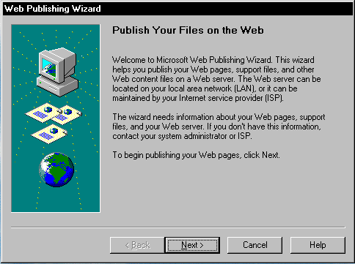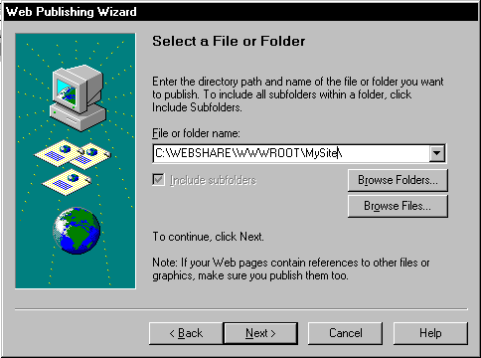

Select the File or Folder that you would like to publish.

Select the Web Server you want to publish to, if this is the first time you are publishing to your Server click the New button.
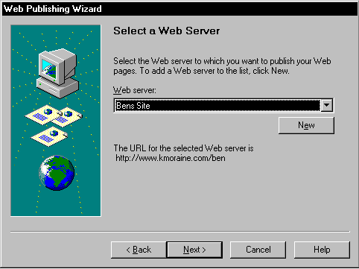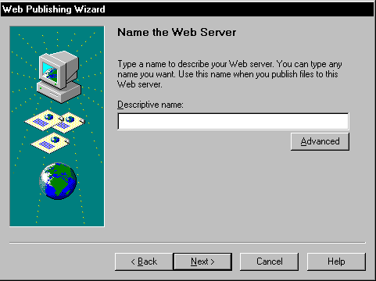

Enter a descriptive name for your Server. Then click the advanced button.

In Select your Service provider. Select FTP then click Next
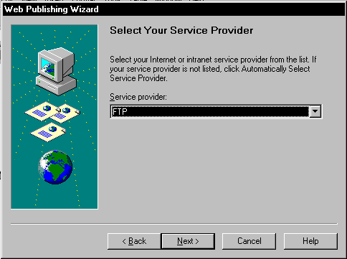
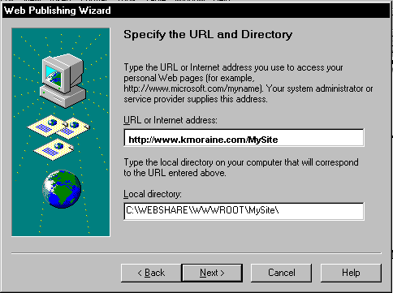Specify the URL and Directory http://www.kmoraine.com/MySite your Local directory should be the files you selected from Select a File or Folder.

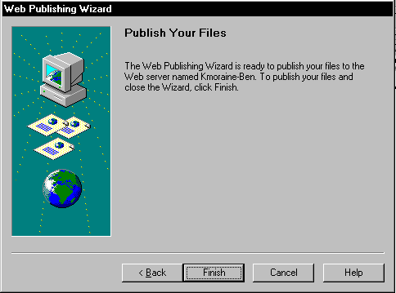Select your FTP Server and Subfolder. In the FTP Server field enter www.kmoraine.com. Leave the SubFolder Blank. Notice that URL for your Web Server and Directory says http://www.kmoraine.com/MySite
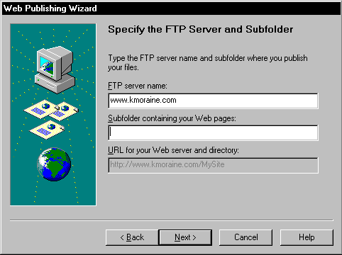

Click Next Then Finish. You will be prompted for your User Name and Password Enter them then click Ok thats it your done.

